Incarceration, reentry, and democracy
What can we learn from the formerly incarcerated?

An Overview of Mass Incarceration in the United States
The United States incarcerates more humans in raw numbers than any other country. In fact, in 2014, the National Research Council reported that “[t]he U.S. penal population of [then] 2.2 million adults [was] the largest in the world [and that] close to 25 percent of the world’s prisoners were held in American prisons, although the United States account[ed] for about 5 percent of the world’s population.” The number today is lower—closer to 20 percent of the world’s prisoners—partly reflecting changes to sentencing policies in a handful of populous states.
It hasn’t always been this way. The United States hasn’t always incarcerated so many people. For a century before the current escalation, the national incarceration rate had fluctuated somewhat, responding mostly to changes in the economy, particularly the unemployment rate. In fact, in the 1970s some criminologists theorized that forces of “societal homeostasis” would constrain the use of imprisonment within a limited range. (Of course, others writing at around the same time did identify an alarming acceleration of the rate of incarceration beginning in the 1970s.) However, although the incarceration rates in 1935, 1955, and 1975 were virtually identical (113, 112, and 111, respectively), the changes that followed in the years since have been nothing short of extraordinary. The 1980s and the ensuing decades saw the United States chart a new course in the use of confinement as social policy. Attempts to describe this historical newness, as well as its international uniqueness, lie behind lexical innovations like prison-industrial complex and mass incarceration. Both phrases emerged toward the end of the twentieth century within movements seeking to address the harms of the U.S. CLS, particularly its disproportionate impact on people of African descent. They then found their way into journalistic and scholarly print.
The aggregation of data in national statistics can hide the most alarming features of mass incarceration. Following the U.S. Civil War (1861–1865), the breakaway states in the South came under direct federal military rule. Former Confederate soldiers were stripped of the right to vote, and the states wrote new constitutions before being readmitted to the Union. During this time, large numbers of African Americans voted. Mississippi sent two Black men to the U.S. Senate, and South Carolina elected a majority-Black state legislature. This period, known as Reconstruction, lasted until federal troops finally withdrew from the South in 1877. However, the U.S. Congress restored the vote to former Confederates in 1872. After regaining the vote, White Southerners retook control of state and local governments, rewrote the new state constitutions, and found ways to circumvent new federal protections related to slavery, equality under the law, and the right to vote that were thought to have been enshrined in the 13th, 14th, and 15th Amendments to the U.S. Constitution. They achieved this reversal of power through a combination of legal machinations and political terrorism. Despite incomplete records, the Equal Justice Initiative has documented 34 mass lynchings throughout the South during Reconstruction (i.e., before the dawn of the period known as the “nadir” of U.S. race relations). In at least five of these, more than 100 Black people were killed by White mobs. In other cases, entire families were lynched, as when Daniel Blue’s wife and five children were murdered by a White mob in Moore County, North Carolina following Blue’s testimony against White men for acts of racist violence. Control of Southern governments quickly reverted to the hands of Whites following the re-enfranchisement of former Confederates, an epidemic of anti-Black violence, and a hands-off policy on the part of the federal government. Well before Reconstruction formally ended, Georgia and Virginia elected former Confederate military officers as governor and all former Confederate states “rewrote their constitutions to restrict voting rights using poll taxes, literacy tests, and felon disenfranchisement.”

Beyond Incarceration: Barriers Faced During Reentry in the United States
In January, 2025, I was fortunate enough to interview Steven Mangual, the southeast justice advocate coordinator for Latino Justice/PRLDEF, a legal reform and advocacy civil rights organization. Mangual served 14 years out of a 24-year prison sentence in New York for a violent felony he committed when he was 20. In the interview, he describes the events of his early life as “typical” for a Puerto Rican young person growing up poor in the Bronx during the 1970s and 1980s: his single mother’s struggles with addiction and mental health, his abusive step fathers, and his gravitation toward gangs, illicit drugs, and crime. He was arrested a half dozen times as a teen, with his final arrest leading to his prison time occurring within a year and half of the death of his mother and sister. He characterized himself as having no hope, no support, and no expectation of a future other than prison. At one point in his incarceration, he spent four months (127 days) in solitary confinement, isolated 24 hours a day, with one hour outdoors but still isolated from other prisoners:
It was like no experience ever. After a while, you know, the sensory deprivation, the inability to control the lighting, and the inability to have regular sleep patterns. There was a lot of noise there Upstate. There was a lot of abuse taking place because people were mentally ill, and they were just being abused by the correctional officers. I was next door to a guy who got beat up badly and taken out, you know, by the [correctional officers]. After a while, you’re just sitting there staring at the walls and they just start moving. (Mangual 14:45–18:20)
Here, Mangual identifies many of the most important features of incarceration beyond confinement and deprivation of liberty: extreme surveillance, violently maintained hierarchies, physical discomfort, mental anguish, and social exclusion.
Scholars like Lisa Marie Cacho and Dylan Rodriguez, following Orlando Patterson, have characterized these features of incarceration as constituting a form of “social death.” Patterson originally described the concept relative to the enslaved human’s loss of legal, social, and familial connections. Despite U.S. courts repeatedly holding that, despite the Thirteenth Amendment, prisoners are not “slaves of the state,” the social death that they experience is profound. Cacho extends this concept to include “racialized rightlessness” and marginalization for incarcerated people and other stigmatized groups (such as immigrants). Key features of social death include deprivation of the status of “person” and of social support from community and kin.
Experts note that around 95% of incarcerated humans in the United States will eventually be released back into society. Furthermore, within three years of release, two thirds of people will be rearrested (recidivate). Unfortunately, the condition of social death often does not end with a person’s release from prison. Formerly incarcerated people face barriers to obtaining housing, employment, education, identification, transportation, public assistance, health care, and sobriety. In the state of Oregon, where I worked for several years with recently released men adjusting to life outside, 50% of people are homeless on day one post-incarceration. In his interview, Mangual recounts being unhoused “four or five” times since his incarceration. As a condition of his parole, he had lined up transitional housing upon release, but he found himself turned away without even a referral because he hadn’t used drugs in over a decade.
The formerly incarcerated are often excluded by institutions of higher education, and if they are admitted, then they often find themselves unable to access financial aid. They often lack transportation to meeting with their parole officer, to attend the court, or to submit to a drug test. They have difficulty managing chronic health conditions like HIV, high blood pressure, or diabetes, for which they received prescription medication while imprisoned. Finding health insurance, getting dental care, and keeping up with psychiatric medications all become massive hurdles. Social death after incarceration is even more severe for people with convictions for many sexual offenses. Sex offender registries leave them vulnerable to violence, discrimination, and ostracization. Formerly incarcerated parents typically lose custody of their children and face barriers to having their rights restored. And, because transitional housing and other services often focus exclusively on men, formerly incarcerated women and trans people are more likely than men to end up on the street.
Despite these many challenges, or perhaps because of them, empirical research has sought to determine what works in helping formerly incarcerated people avoid going back to prison. A massive 2012 study supported by the National Institutes of Justice found that programs offered before release that focused on addiction treatment, “cognitive-focused programs,” and education were moderately beneficial, while programs like reentry preparation, life skills programs, and employment services were sometimes found to be counterproductive. Yet research has shown for decades that connections to family and participation in civic life are positively correlated with successful reentry. One recent study concluded, “Family support appears to relate to prosocial reentry outcomes not because of emotional or interactional bonds, but because families provide for the basic needs of returning individuals. Instrumental familial support mechanisms such as providing housing and financial support appear more salient in promotion prosocial reentry outcomes than [other mechanisms].” Similarly, democratic participation (understood as “civic literacy, democratic skill development, civic attachment, and political activism”) has been prosed as a way to encourage prosocial outcomes and to reduce the risk of rearrest. One of the most prominent barriers to democratic participation for the formerly incarcerated that scholars have considered is the abridgment of voting rights.

Establishing the Vote: Reshaping Democratic Participation in the United States
The United States actively tends to restrict democratic participation for some even as it expands participation to new categories of people. One, out of many, sources for this tendency is partisanship and the zero-sum nature of the U.S. political system. If a party cannot attract more voters, it can seek to disenfranchise those who might vote otherwise, either directly through voting barriers and restrictions or indirectly through various forms of gerrymandering. However, it can be difficult to see this as a permanent feature of the country’s political system because the triumphal narrative of a continuously expanding electorate is so celebrated and central to public accounts of the nation’s history. Most recently, the expansion of voting rights entailed the nation-wide enfranchisement of people aged 18 to 21 following passage and ratification of the Twenty-sixth Amendment in 1971. Coincidentally, later that same year, Attica Prison in Upstate New York was rocked by what still stands as the deadliest prison revolt in U.S. history. By end of the five-day takeover of the prison and its retaking by state police, 43 humans had died and at least 91 were injured. The violence of the Attica Uprising and other aspects of the broader movement in U.S. prisons that spanned from the late 1960s into the decade of the 1980s brought attention to the use of incarceration to restrict participation in both the operation of the state and civil society by citizens deemed to have forfeited rights to such participation by virtue of criminal conviction. Rather than tracking expansion and contraction of the franchise in separate timelines, I would like begin by reflecting on these two, opposite tendencies and how they have worked in tandem.
When the U.S. Constitution took effect in 1789, it guaranteed men the right to vote if they were free, owned property, and could claim to be racially white. Since U.S. elections are run at the state level, however, states were able to extend the right to vote beyond the Constitutional bounds. Notably, in New Jersey not only were free, property-owning men of color allowed to vote, but women were as well. Indeed, at least one free Black woman likely voted in New Jersey before 1807. When Vermont was admitted to the union in 1791, it allowed all men—without regard to race or property—the right to vote, as did Kentucky the following year. Engerman and Sokoloff have demonstrated that
White men might come to believe that differentiation on the basis of wealth was unfair, unreasonable, or inconsistent with basic rights . . . [b]ut they remained comfortable supporting the exclusion of groups that were, in their view, obviously distinctive and unsuitable for participating in community decisions: blacks, women, children, Native Americans, the mentally incompetent, those with criminal records, and those (immigrants as well as native born) who had not long been resident in the county or state. When there were wealth-based restrictions, there had been no real need for provisions that dealt specifically with these classes, but as states eliminated or weakened the economic-based qualifications, there was increasing emphasis on introducing or tightening qualifications that would keep undesirable groups out of the electorate. At the same time that Delaware, Maryland, Connecticut, New Jersey, and Pennsylvania eased their economic qualifications, each altered its constitution to exclude blacks.
The mechanism for this transformation of the electorate—expanding to include some while contracting to exclude others—typically took the form of “a package of reforms” that would be “adopted altogether.” Thus, restrictions pertaining to race, length of residence, and sound mental capacity would be added at the same time that “economic-based qualifications” were removed:
It is notable that despite virtually all of the new states beyond the original 13 entering the union with weak or no economic-based requirements for the franchise, Kentucky . . . and Vermont were the only ones that allowed blacks to vote. The list of those that never allowed blacks to vote before the Fourteenth Amendment include California, Colorado, Illinois, Indiana, Iowa, Kansas, Michigan, Minnesota, Missouri, Nebraska, Nevada, Ohio, Oregon, Utah, Wisconsin, as well as all of the southern states.
In the former colonies that had initially permitted property-owning free Black men the right to vote, that right began to be chipped away at in the early nineteenth century. Whereas free African Americans were not explicitly barred from voting in ten of the thirteen original states (excepting Georgia, South Carolina, and Virginia), by 1807, New Jersey, Delaware, and Maryland had all barred free Blacks from voting. Pennsylvania disenfranchised free Black men beginning in 1837.
In the wake of the Civil War, free Black men gained the right to vote in Wisconsin and the District of Columbia before the Fourteenth Amendment barred the abridgement of privileges of citizenship (including the right to vote) in 1868. Rather than directly extending the right to vote, the Fourteenth Amendment provides that states which restrict the right of male citizens to vote should have their presentation in Congress proportionately reduced. The Amendment provides one important exception: States may deny voting rights to such men without penalty “for participation in rebellion, or other crime.” The Fourteenth Amendment, while ostensibly guaranteeing more citizens the right to vote simultaneously sets the conditions according to which access to the ballot could be effectively repealed on a large scale. The Fifteenth Amendment, passed shortly afterwards, is the Reconstruction Amendment most often associated with voting rights. It explicitly prevents states from restricting the franchise due to “race, color, or previous condition of servitude.” It was carefully written to prevent certain kinds of discrimination, however, rather than to affirm universal suffrage. Thus, once again, voting restrictions did not simply expand but were reshaped. Most notably, the racial restrictions on voting by free Black men transformed into other constitutional restrictions such as poll taxes, literacy and civics exams, and grandfather clauses. While racially neutral on their face, they were, as history tells us, nearly universally enforced so as to disenfranchise nonwhites—even as the franchise was extended to women in by the 19th Amendment in 1920.

Restricting the Vote: Felony Disenfranchisement Laws in the Courts
Before 1860, 17 states barred those with serious criminal convictions from voting in elections. This number more than doubled in the wake of the Civil War (1961–1965), the Emancipation Proclamation (1963), Reconstruction (1865–1877), and Redemption (1877–1900) (Fig. 1). This rush to bar people with convictions from voting is one of many facets of the U.S. criminal legal system that sets it apart from other countries. People serving time vote from prison in countries ranging from Australia and New Zealand to Canada and Peru to the European Union and Israel to Kenya and Zimbabwe to China and Japan.
The practice has not gone unchallenged in the courts. In 1974, the U.S. Supreme Court ruled in Richardson v. Ramirez that felony disenfranchisement does not violate the Fifteenth Amendment, but ruled in Hunter v. Underwood a decade later that disenfranchisement would violate the Constitution if it had “a racial motivation and racially discriminatory impact.” This ruling was based on legislation that Congress passed to guarantee voting rights, specifically the Voting Rights Act of 1965 as amended in 1982:
A violation of subsection (a) of this section is established if, based on the totality of circumstances, it is shown that the political processes leading to nomination or election . . . are not equally open to participation by members of a class of citizens protected by subsection (a) of this section in that its members have less opportunity than other members of the electorate to participate in the political process and to elect representatives of their choice.
In response to the amendment of the Voting Rights Act and the Court’s apparent openness to consider felony disenfranchisement as a potentially impermissible restriction of the right to vote, prisoners began challenging these statutes. In Baker v. Pataki (1996), the Second Circuit split on the question of whether or not the Voting Rights Act could be applied to people in prison. Eight years later, the same Circuit clarified that it did not believe the Voting Rights Act could apply to prisoners without a “clear statement” of intent from Congress. They reasoned that if Congress had intended it to apply, it would have indicated so when it amended the statute in 1982. Another defeat came from the Eleventh Circuit in 2005, when they ruled in Johnson v. Bush that the Voting Rights Act could not apply to prisoners.
At this point, the Supreme Court had yet to weigh in on the issue, but a 2006 case from the Ninth Circuit gave them an opportunity that they took. In Farrakhan v. Gregoire, the Circuit Court found that the Voting Rights Act did, in fact, apply to imprisoned people who had been convicted of felonies. In doing so, it ruled that the lower, district court erred in not considering evidence of disproportionate imprisonment as evidence of racial discrimination. The state appealed, and the Supreme Court refused to hear the case, letting the Ninth Circuit ruling stand. The case thus landed back in the Eastern District of Washington State, which found that there was “discrimination in Washington’s criminal justice system,” but that the discrimination it found was not sufficient to balance out the lack of intent to discriminate in Washington’s original statute: “Washington’s history, or lack thereof, of racial bias in its electoral process and in its decision to enact the felon disenfranchisement provisions, counterbalance the contemporary discriminatory effects that result from the day-to-day functioning of Washington’s criminal justice system.” On a second appeal, the Ninth Circuit found Washington’s low to violate the Voting Rights Act, but then reheard the case en banc (rather than before a three-judge panel). This time, the court upheld the lower court’s opinion. Three years later, in Shelby v. Holder (2013), the U.S. Supreme Court gutted sections 4 and 5 of the VRA, leading to more than 100 new voting restrictions passing in states across the country.
Criminal disenfranchisement is unequivocably legal in the United States—after all, as the Ninth Circuit noted in its en banc decision, Congress was well aware of these laws when it passed the VRA in 1965 and when it amended it in 1982. The only way to challenge it would be to demonstrate that a criminal legal system is “infected by intentional discrimination,” the standard for most discrimination claims since Washington v. Davis (1976). Voting, perhaps along with jury service, holds a central place in the U.S. imagination as a right that is central to the functioning of democracy. Some states have responded to disenfranchisement by modifying their laws. Twenty-three states now automatically restore voting rights upon release from prison. By contrast, only three states permanently disenfranchise those with felony convictions.

Beyond the Vote: Fostering Democratic Participation Outside of the State
Criminal disenfranchisement is not the only mechanism by which a disfavored group in the United States experiences social death. As Cacho demonstrates, undocumented immigrants experience a similar social death. In the words of Nicholas De Genova,
Beginning in the 1960s, precisely when Mexican migration escalated dramatically—and ever since—persistent revisions in [immigration] law have effectively foreclosed the viable possibilities for the great majority who would migrate from Mexico to do so in accord with the law, and thus played an instrumental role in the production of a legally vulnerable undocumented workforce of “illegal aliens.”
Indeed, the limiting of legal pathways to citizenship despite the necessity of low-wage Mexican labor for the U.S. economy has resulted in something akin to the “new Jim Crow” experienced by Black people with criminal convictions.
Without going into too much detail about federal immigration policies, I will note that immigrant visa issuances during fiscal year 2023 were limited to no more than 226,000 in the family-sponsored preferences and 140,000 in the employment-based preferences. (There is no limit on visas issued to immediate relatives.) These 366,000 visas account for the most accessed means of lawfully immigrating. There is a 7% per-country limit on visa issuances to any single country, meaning that the per-country limit was 58,800 in 2023. But Mexico, the largest sending nation to the United States, had 1,224,062 applicants on the waiting list for an immigrant visa in 2020, and in 2022, the United States was still finalizing Mexican family-sponsored visa applications from 2000—applications that were nearly two decades old (Figure 2). In other words, legal immigration from Mexico to the United States is effectively impossible, by design. One result is a large, visibly Mexican population, especially in border states, who live, work, and pay taxes in the United States for long periods of times (sometimes for life) with no right to vote. In 2014, Latines made up 38.6% of California’s population, but only 28% of its electorate. And most Latines in California were ineligible to vote (Figure 3). Yet, undocumented Latines have found many ways to participate in the civic life of the United States.
Anthropologist Renato Rosaldo defines “cultural citizenship” as “the right to be difference (in terms of race, ethnicity, or native language) with respect to the norms of the dominant national community, without compromising one’s right to belong, in the sense of participating in the nation-state’s democratic processes.” He continues, “From the point of view of subordinated communities, cultural citizenship offers the possibility of legitimizing demands made in the struggle to enfranchise themselves. These demands can range from legal, political, and economic issues to matters of human dignity, well-being, and respect.” Finally, “cultural citizenship includes and also goes beyond the dichotomous categories of legal documents, which one either has or does not have, to encompass a range of gradations in the qualities of citizenship.” From protests and marches to petitions and strikes to mutual aid and community associations, immigrants with and without documents have engaged in civic and political participation in the United States for decades. This participation has laid the groundwork for staking a claim to belonging and for further political action. For Rosaldo, it is guided by a telos aimed at inclusion as full citizens. However, that aim is not a necessary one. What I like about cultural citizenship is that it can represent an alternative to state incorporation.
Returning to the context of reentry, rather than viewing “social death” as an endpoint, we can understand it as opening out onto other possibilities for civic involvement. In his interview, Mangual illustrates what these possibilities might be and how they benefitted him. Early in his incarceration, he was introduced to the “Nontraditional Approach to Criminal and Social Justice” developed by Eddie Ellis, Larry White, and other survivors of the 1971 Attica Rebellion. The Non-Traditional Approach emerged within New York prisons in the 1980s from question posing about “the escalating cycle of social poverty and crime.” The Approach seeks to integrate individual offender treatment with an analysis of socio-economic and political discrimination. It stresses the importance of building and maintaining connections between incarcerated humans and their communities of origin. Rather than emphasizing “rehabilitation,” it emphasizes “empowerment.”
I was doing a lot of organizing, a lot of reading, writing, a lot of self-reflecting, a lot of taking accountability, a lot of therapy. I did a lot of cognitive-behavioral therapy while I was incarcerated, both as a person who needed therapy and as a peer educator in therapy. So, by the time I got to the box at Upstate, I had all of this behind me. I had a lot of support, community support. I was part of a class action law suit.
Central to the Non-Traditional Approach are three themes: Crime Generative Attitudes, Ethnic States and Identity, and Sense of Community (see Figure 4). Mangual’s extensive work while incarcerated included becoming a peer educator, a health educator, and an American Sign Language interpreter as well as participating in restorative justice circles through which he and other prisoners held each other accountable for their actions.
Mangual’s own characterization of the Non-Traditional Approach is as a model of empowerment through social justice and transformation:
The package, the Non-Traditional Approach, it gave us a language. It gave us a sense of identity. It held us accountable through . . . responsibility and reconciliation and atonement. It taught us that we were the experts—those who were inside—we were the experts in this because we lived it. And not just lived it, but we’re authentically transforming our lives and helping transform our communities and rebuild those places that we destroyed, when we went back.
In his account, this work prepared him for reentry and reintegration. But the empowerment work and political action that he took in prison didn’t make him appear ready for release from an institutional perspective. He was a plaintiff in multiple class action suits, including a voting rights case, Hayden v. Pataki. Participation in one of these, he felt, led to his 127-day stint in solitary, but he credits getting out of solitary to the connections to movement lawyers he forged during those cases. Even while in solitary, he found ways to communicate with other prisoners and to support each other through singing songs and passing notes.
After being turned away from transitional housing upon his release, he turned to his community again. His mother and sister were dead and his remaining sister was herself in a halfway house. But connections he had made with other prisoners and former prisoners through the Non-Traditional Approach enabled him to find both housing and employment. For eleven and a half years, he worked as a health educator. For the first three years, he was still on parole, working within unhoused and formerly incarcerated people many of whom were on parole themselves. His eventual position with Latino Justice also stemmed from connections he made during his incarceration.
Traditional approaches to reentry focus on the roles of criminal justice and mental health professionals and social workers in rehabilitating people in custodial supervision. The Non-Traditional Approach centers incarcerated and formerly incarcerated people themselves as the important agents in the empowerment of themselves, each other, and their communities. And yet, although we know anecdotally that many formerly incarcerated people find careers working with reentry services and substance abuse treatment, there has been little research on their contributions to helping others reintegrate with society and to avoid rearrest. But the formerly incarcerated have not waited for researchers to catch up. An archipelago of nonprofits and service organizations exist across the United States, many founded by the formerly incarcerated. One network of these comes together as the Formerly Incarcerated and Convicted People and Families Movement (FICPFM) (Figure 5). Mangual says that through everything, it was his community that helped him stay out of prison after reentry:
It was my community. It was my family, who I call family, the folks I met with while I was incarcerated that I’m still connected to. It was all of those folks who were there for me. And, it was my training and my realizing and understanding that there was just no way I was gonna to do anything to risk my freedom again. Because it wasn’t just my freedom. I’m responsible and accountable to my community. I’m responsible and accountable to my mentors, to my mom.
After I pressed him on what helped him to succeed when so many fail despite their efforts, he said, “My biggest support is folks like me. Folks who are formerly incarcerated, folks who are going through it, like me. Folks who are directly impacted. Families of the formerly incarcerated. Advocates who understand what it is to go through this kind of reentry and reintegration from a traumatic experience and carrying this felony conviction.” Reentry from prison isn’t easy under the best of circumstances. By foreclosing opportunities for civic participation, by imposing social death on the formerly incarcerated, by punishing them for forming community with others like them, and by demonizing their political participation, our criminal legal system betrays an preference for preserving social inequality over expanding democracy.

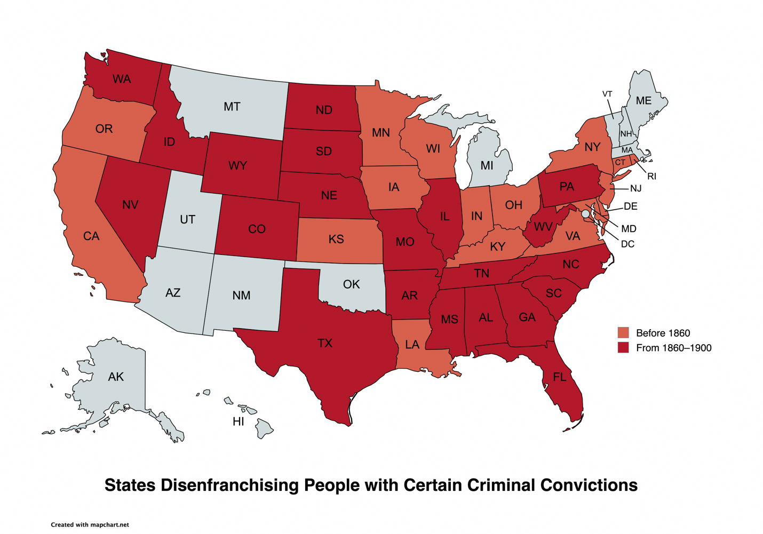
Figure 1

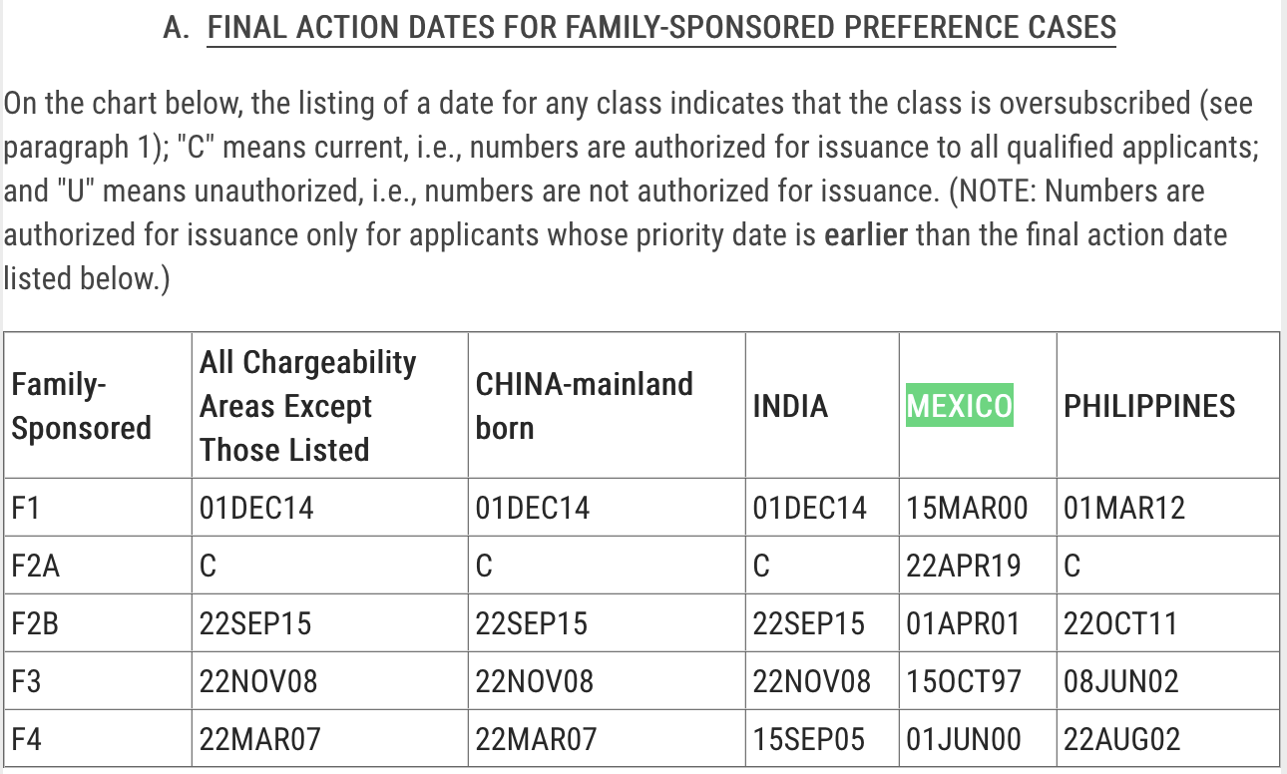
Figure 2

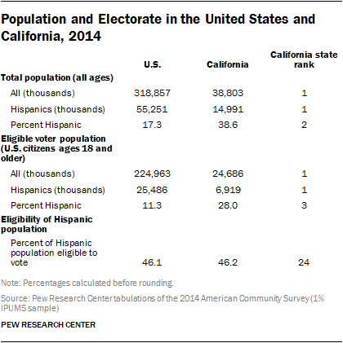
Figure 3

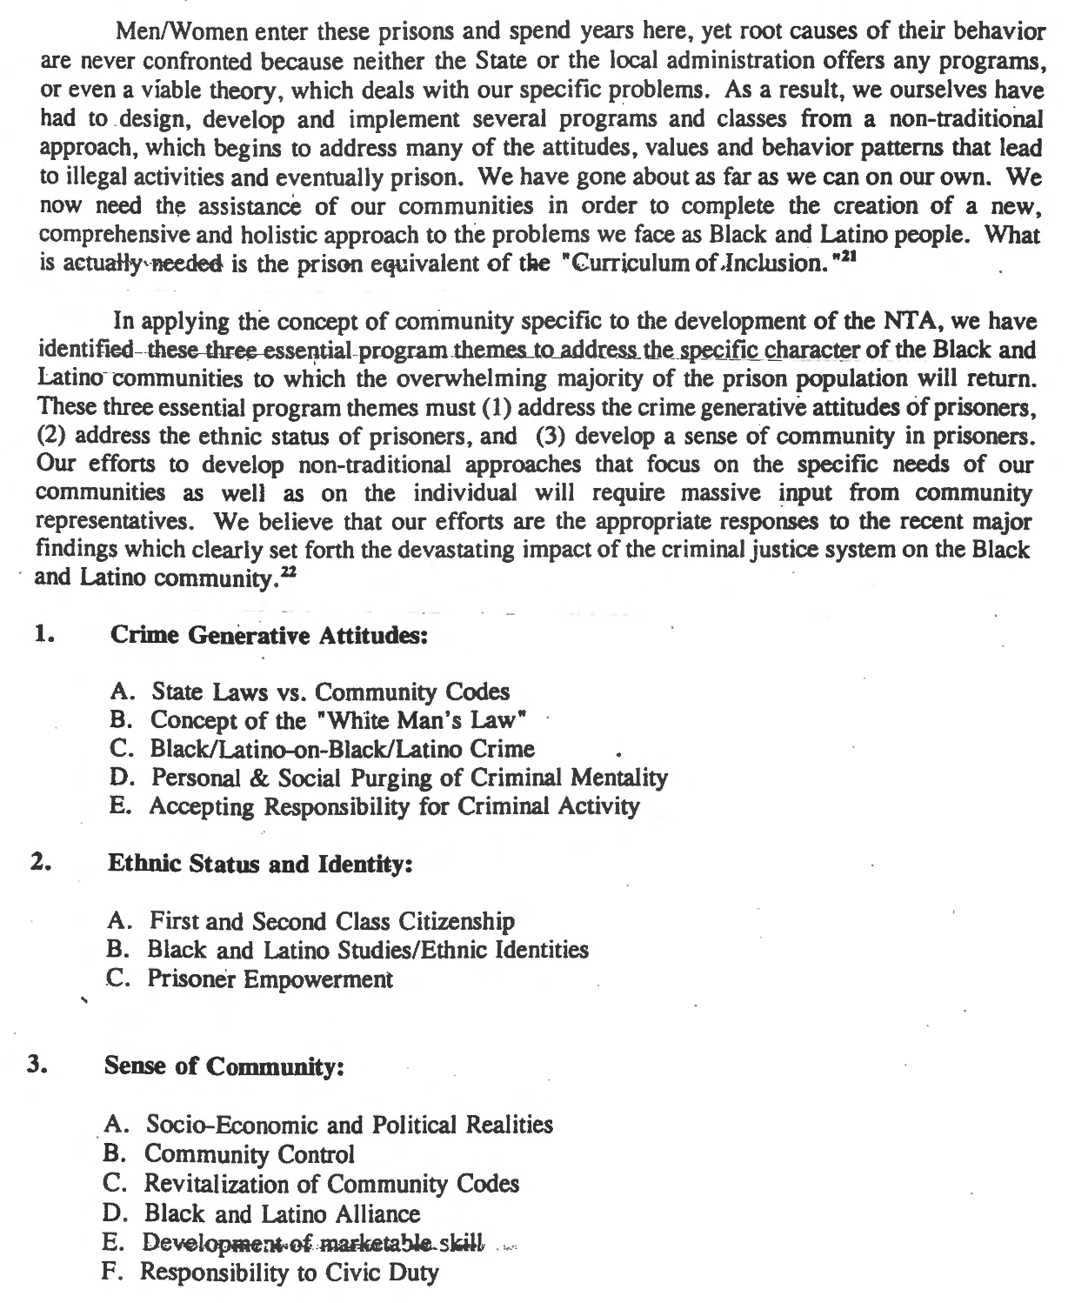
Figure 4

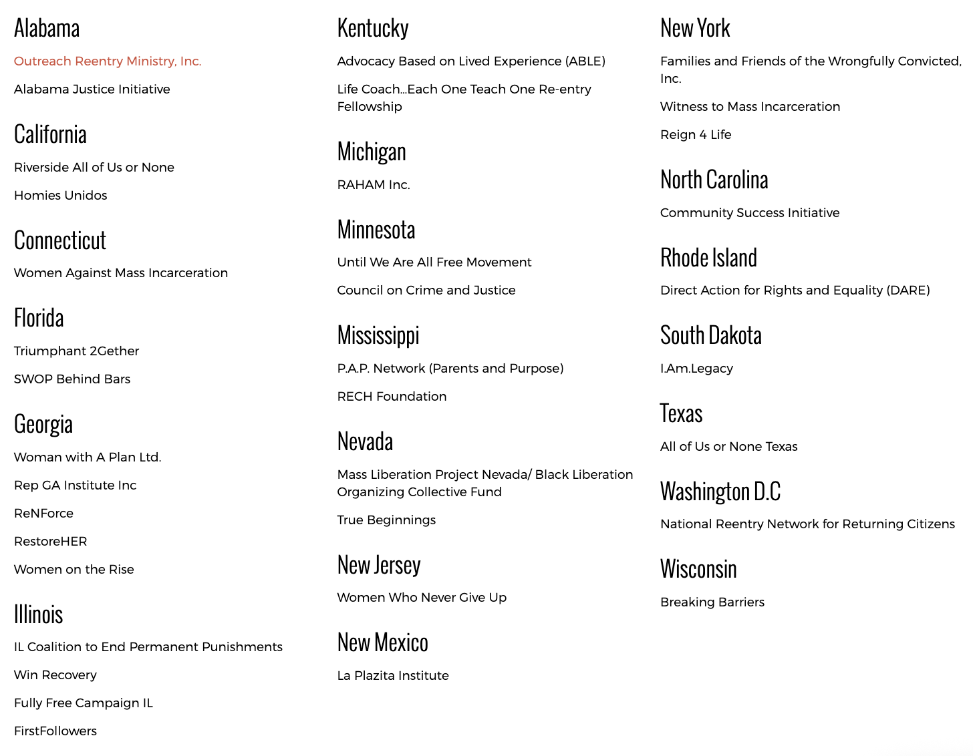
Figure 5

National Research Council, The Growth of Incarceration in the United States: Exploring Causes and Consequences, 2, (2014). This figure circulated widely in the 2010s, making it into the talking points of Hillary Rodham Clinton’s presidential campaign. See Lee, M. Y. H. (2015), Does the United States really have 5 percent of the world’s population and one quarter of the world’s prisoners? The Washington Post, April 30; Office of Hillary Rodham Clinton, Criminal justice reform, https://www.hillaryclinton.com/issues/criminal-justice-reform/ (accessed November 13, 2023).
See Porter, N. D. (2014), The state of sentencing 2013: Developments in policy and practice, The Sentencing Project.
See Blumstein, A., and Nagin, D. (1978), On the optimum use of incarceration for crime control, Operations Research, 26(3), 381–405, http://www.jstor.org/stable/169751. See also Blumstein, A., and Cohen, J. (1973), A theory of the stability of punishment, Journal of Criminal Law and Criminology, 64(2), 198–207. https://doi.org/10.2307/1142990; Blumstein, A., Cohen, J., and Nagin, D. (1977), The dynamics of a homeostatic punishment process, Journal of Criminal Law and Criminology, 67(3), 317–334, https://doi.org/10.2307/1142865.
See Cahalan, M. (1979), Trends in incarceration in the United States since 1880: A summary of reported rates and the distribution of offenses, Crime & Delinquency, 25(1), 1–127, https://doi.org/10.1177/001112877902500102.
Du Bois, W. E. B. (2021), Black reconstruction: An essay toward a history of the part which Black folk played in the attempt to reconstruct democracy in America, 1860-1880, & other writings (E. Foner & H. L. Gates, Eds.), Library of America; Eric Foner, Reconstruction: America’s Unfinished Revolution, 1863-1877 (Updated ed. 2014); Ayers, E. L. (15th anniv. ed. 2023), The promise of the New South: Life after Reconstruction, Oxford University Press; Lemann, N. (2006), Redemption: the last battle of the Civil War, Farrar, Straus and Giroux; Franklin, J. H. (2013), Reconstruction after the Civil War (3rd ed.), University of Chicago Press;.
Litwack, L. F. (1979), Been in the storm so long: The aftermath of slavery, 502–556
Equal Justice Initiative (2020), Reconstruction in America: Racial violence after the Civil War, 1865–1876, https://eji.org/report/reconstruction-in-america/
Rawley, J. S. (1960), The General Amnesty Act of 1872: A note, Journal of American History, 47, 480–84.
Perman, M. (2001), Struggle for mastery: Disenfranchisement in the South, 1888–1903, University of North Carolina Press).
Alexander, S. L. (2015), Reconstruction violence and the Ku Klux Klan Hearings, Bedford/St. Martins.
Equal Justice Initiative (2020), 48–49.
Rayford W. Logan, The Betrayal of the Negro, 88–104 (rev. ed. 1997).
Equal Justice Initiative (2020), 48–49.
Equal Justice Initiative (2020), 49.
Equal Justice Initiative (2020), 95.
Lisa M. Cacho, Social Death: Racialized Rightlessness and the Criminalization of the Unprotected (2012); Dylan Rodríguez, Forced Passages: Imprisoned Radical Intellectuals and the U.S. Prison Regime (2006). See also Orlando Patterson, Slavery and Social Death: A Comparative Study (1982).
Kimberly Collica-Cox, “Civic Engagement for the Future Criminal Justice Professional: Serving the Underserved in a Correctional Setting,” 12(2), 10 Journal of Community Engagement and Scholarship (2022).
Keesha Middlemass, Convicted and Condemned: The Politics and Policies of Prisoner Reentry (2017); Keesha M. Middlemass & Calvin John Smiley (eds.), Prisoner Reentry in the 21st Century: Critical Perspectives of Returning Home (2020).
Blair Ames, “NIJ-Funded Research Examines What Words for Successful Reentry,” 281 NIJ Journal (2019); Jennifer L. Doleac, “Wrap-Around Serivces Don’t Improve Prisoner Reentry Outcomes,” 2, 508 Journal of Policy Analysis and Management (2019).
Thomas J. Mowen, Richard Stansfield, & John H. Bowman IV, “Family Matters: Moving Beyond ‘If’ Family Support Matters to ‘Why’ Family Support Matters during Reentry from Prison” 56, 483 J Rsch Crime Delinq (2018).
Gordon Bazemore & Jeanne Stinchcomb, “A Civic Engagement Model of Reentry: Involving Community through Service and Restorative Justice” 68(2) Federal Probation: A Journal of Correctional Philosophy and Practice (2004).
For much of this paper, I will focus on voting as a paradigmatic instance of democratic participation, albeit a limited one and perhaps not even the best measure, so I will return to considering other democratic forms further on. At this point, I will simply acknowledge that voting is an imperfect measure of democracy and ask for readers’ patience while I consider it.
Heather Ann Thompson, Blood in the Water: The Attica Prison Uprising Of 1971 and Its Legacy (2016).
Michael Hames-Garcia, Fugitive Thought: Prison Movements, Race, and the Meaning of Justice (2004); Eric Cummins, The Rise and Fall of California’s Radical Prison Movement (1994); Dan Berger, Captive Nation: Black Prison Organizing in the Civil Rights Era (2014); Dan Berger, The Struggle Within: Prisons, Political Prisoners, and Mass Movements in the United States (2014); Dan Berger & Toussaint Losier, Rethinking the American Prison Movement (2017); Robert T. Chase, We Are Not Slaves: State Violence, Coerced Labor, and Prisoners’ Rights in Postwar America (2020).
Stanley L. Engerman & Kenneth L. Sokoloff, The Evolution of Suffrage Institutions in the New World, 65 J. Econ. Hist. 891, 903, n.26 (2005).
Id. at 903–04.
Id. at 903, n.26.
Alexander Keyssar, The Right to Vote: The Contested History of Democracy in the United States 20 (2000).
Jeff Manza & Christopher Uggen, Locked Out: Felon Disenfranchisement and American Democracy (2006).
52 U.S. Code § 10101.
Nicholas De Genova, “The Legal Production of Mexican/Migrant ‘Illegality’” 2, 160 Latino Stud. (2004).
Renato Rosaldo, “Cultural Citizenship in San Jose, California” 17(2) Pol. & Legal Anthropology Rev. (1994) 57–63. See also, William R. Flores & Rina Benmayor (eds.), Latino Cultural Citizenship: Claiming Identity, Space, and Rights (2004).
Prisoner’s Alliance with Community, “The Non-Traditional Approach to Criminal & Social Justice,” rev. ed. (1997).
Thomas P. Lebel, Matt Richiue, & Shadd Maruna, “Helping Others as a Response to Reconcile a Criminal Past: The Role of the Wounded Healer in Prisoner Reentry Programs” 42, 108 Criminal Justice and Behavior (2015).

